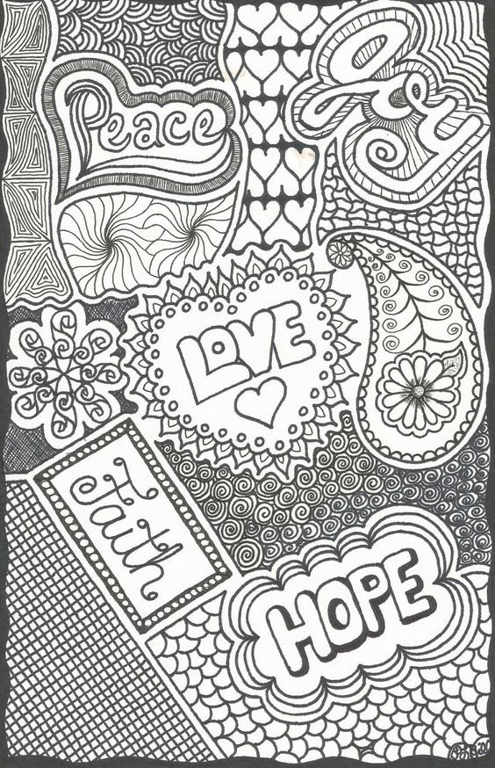
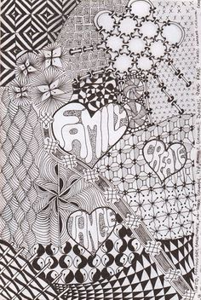
Zentangle with a Message

Project Goal:
You will build on your previous understanding of zentangles and you will be adding a positive message within your composition. In keeping with the concept of zentangles, your composition will consist of beautiful and intricate tangles ‘patterns’ that are separated by a fluid line ‘string.’

Project requirements:
3 words that are inspirational and hopeful.
The words should have a hierarchy of structure - meaning 1 should stand out as the most important, through scale and boldness. The other 2 words will be the supporting words and be smaller and less noticeable.
At least 10 sections with different Zentangles in them.

Day 1 Procedures:
- Select a sheet of paper at least 8.5”x11”. If you don’t have a blank unlined paper get creative, a back of a notebook, piece of cardboard, colored unlined paper (not too dark). Look around and see what you can use.
- Draw a “string” or flowing line that crosses itself throughout the entire page.
- Do this lightly so you can erase the lines that go into the letters.
- You want to have a lot of different sections for your tangles - at least 10. *Use Pencil ONLY
- Draw in 3 INSPIRATIONAL OR HOPEFUL words
- One word should be larger (more important) than the other 2
- They don’t have to entirely fill a sections
- Take a picture and upload to Classroom. You should have something that looks like this to turn in today.
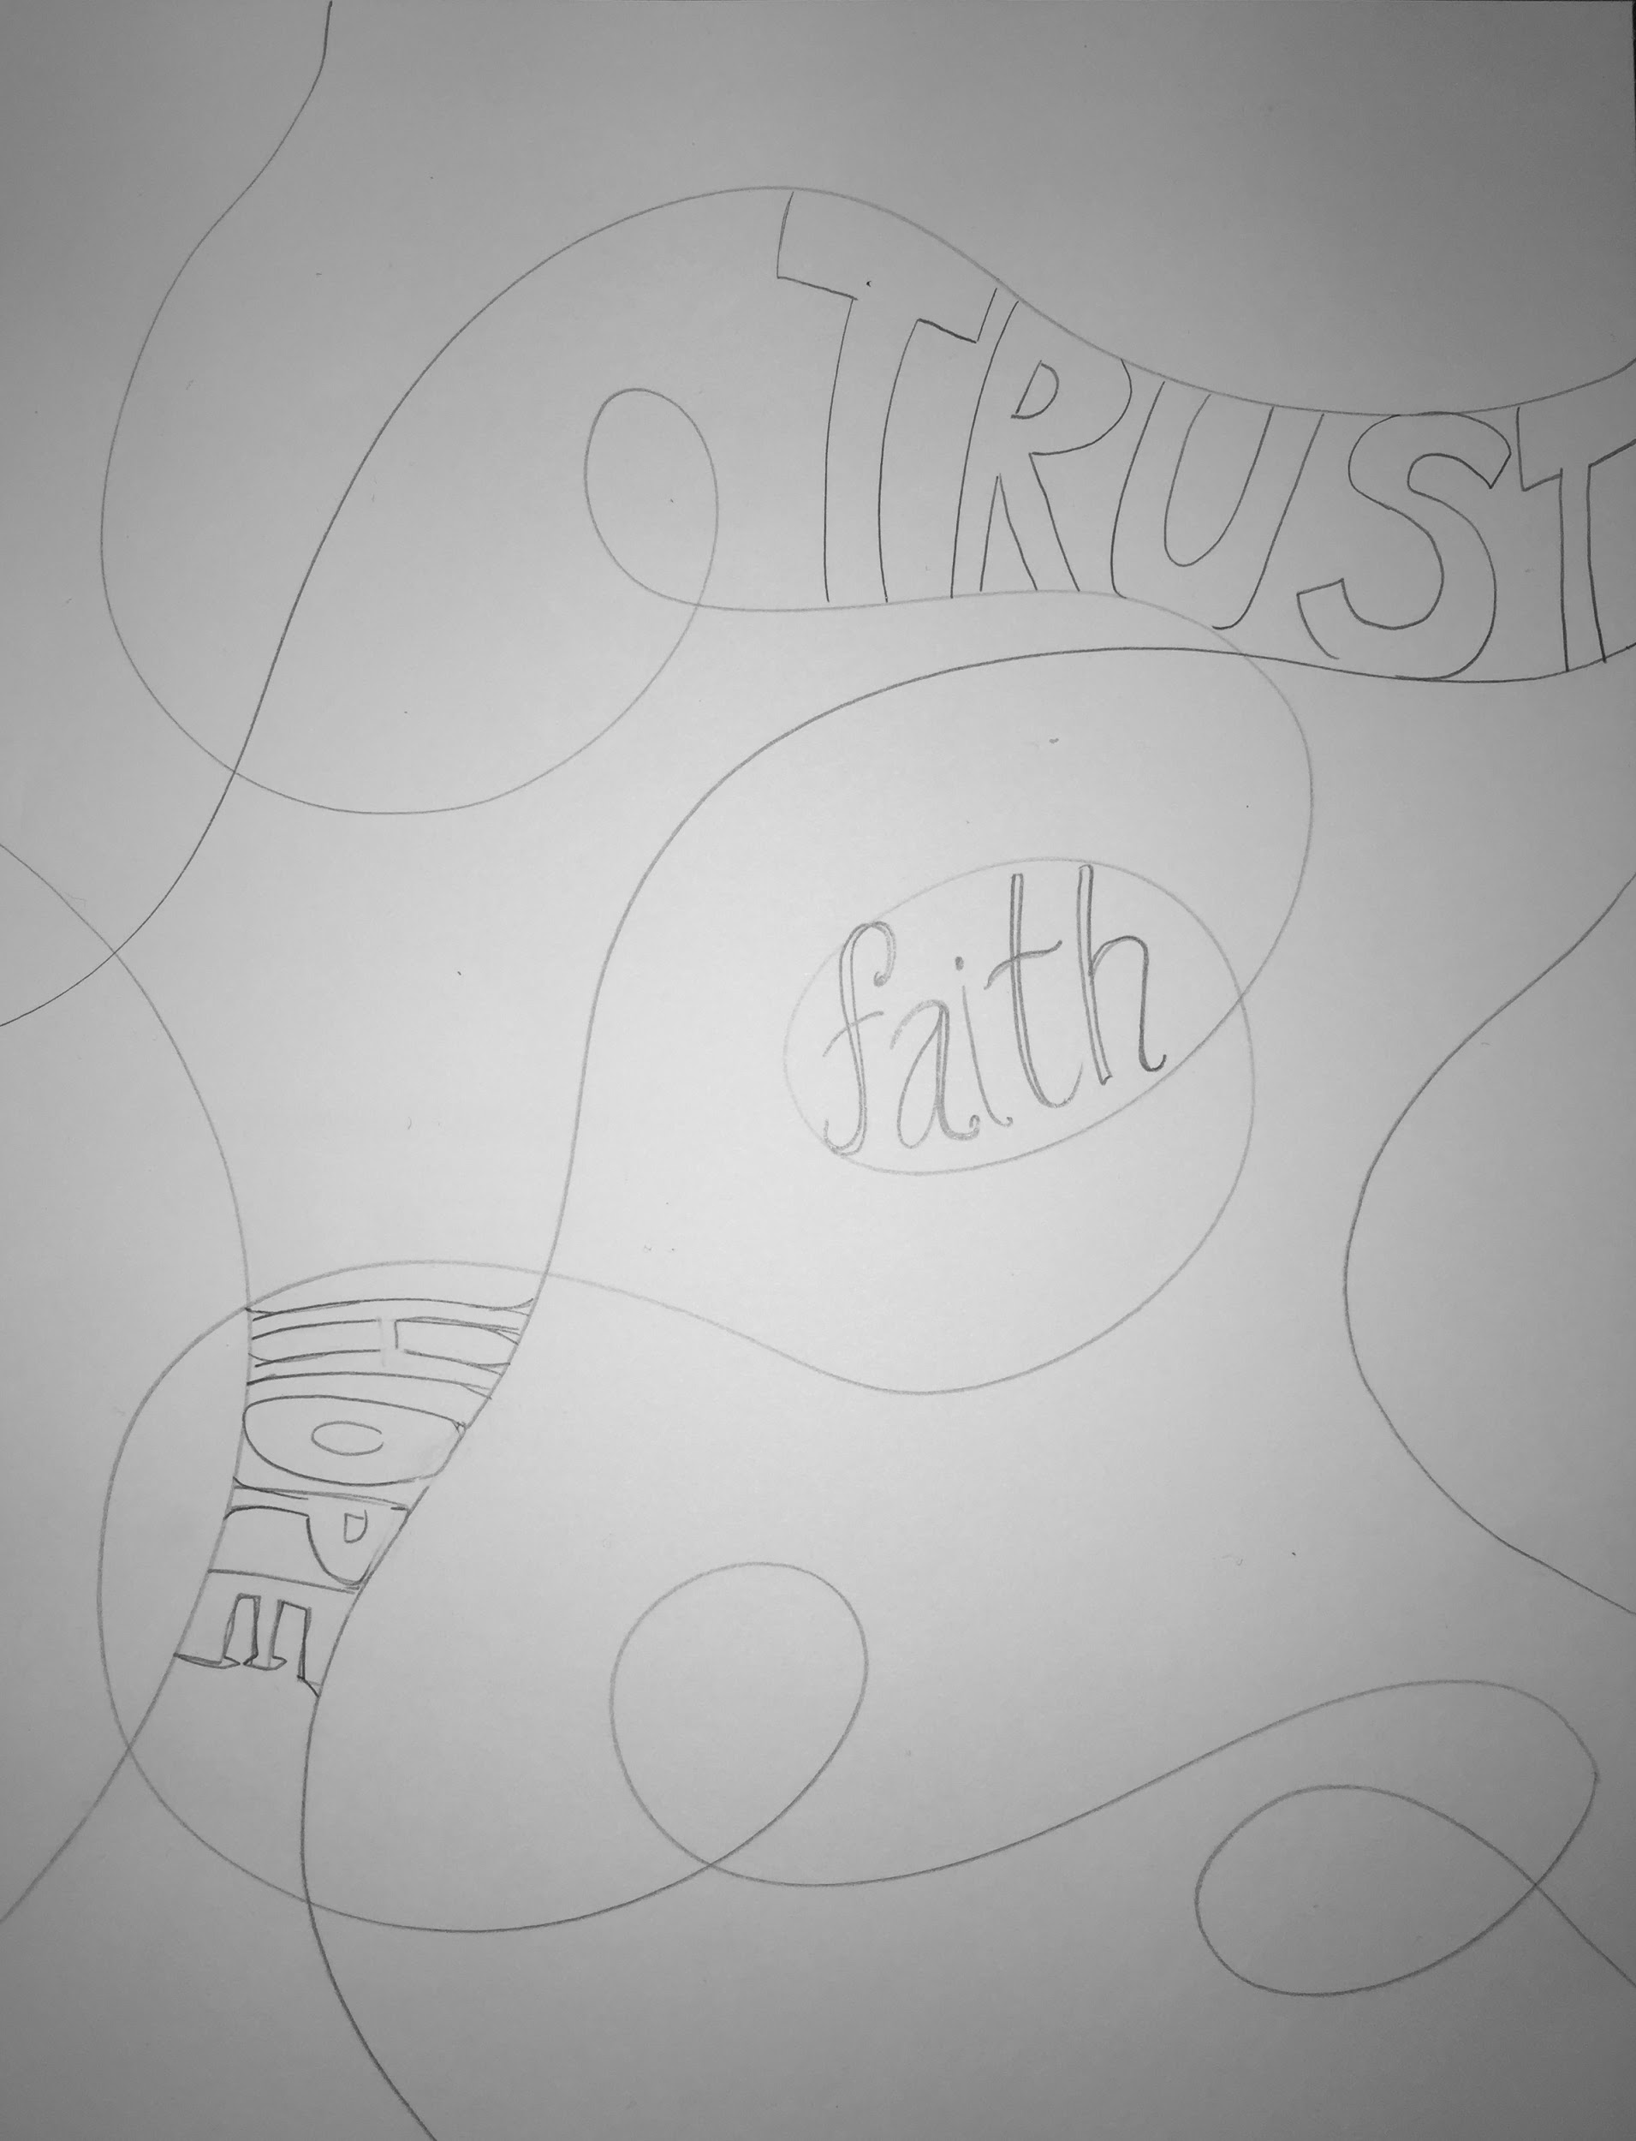
- DO NOT THROW OUT - we are going to add to it.

